1. **Introduction**
   1. PURPOSE

Interior design describes a group of various yet related projects that involve turning an interior space into an effective setting for a range of human activities that are to take place there. Home-makers are looking for a solution that could help them make beautiful homes, without too much hassle. This includes: An easy way to select an interior designer for coordinating a project and to select good quality, well-designed, competitively priced and dependable furniture. An interior designer database is a highly beneficial service available for both the interior designers and the customers. It provides the customers the convenience to choose from a wide array of furnishing products available in the market and also opt for an interior designer who is ready to provide services as per the customer requirements and specifications. Interior Designers too can enhance their Market base and cater to a broader section of the society.

* 1. SCOPE

The present system for interior design includes two distinct portals, one dealing with furnishing products available through online vendors and another dealing with conceptual studios of individual interior designers. The scope of our project is to develop a platform which provides relevant information on products and services that are available to customers in the field of interior designing focusing mainly on Furnishing and Home Décor. The focus not only lies on the database of furnishing products available to customers but also a database of interior designers as employees who offer services. Also a database of customers and their projects is maintained.

The Interior Designer Database management system provides a user interface for viewing a range of home furnishing products. A unique account is provided to each of the customers which contains the project specifications and the status of the project. We develop a web based application which serves as a platform for communication between interior designers and customers (clients).

Front end: PHP & HTML5 & CSS3

Back end: MySQL

Suitable Web Browser for clients. (Ex: Mozilla Firefox, Chrome etc.)

1. **Software Requirement Specification**

SOFTWARE REQUIREMENT SPECIFICATION (SRS) is an important part of software development process. SRS includes overall description, functional requirements, non-functional requirements, performance requirement, design constraints etc. for any applications. These contents are very much useful in fulfilling the goals while implementing software projects.

Product functions: The functions of Interior design database management system are

* It should allow the administrator to enter details of new furniture and furnishing products into the database.
* The customers can browse through the catalog and select furniture they wish to buy. The purchase is completely transparent to the customer.
* Information regarding the purchase such as price of product, taxes and the grand total is generated and given to the user.
* User Characteristics: Only the administrator is provided with the privileges to alter the database system. The customer can only view the contents of the database.
* Customers can view details of interior designers and assign their projects to the interior designer of their choice. A description of the details of their projects and information regarding its status of completion are available to the customer through his unique account.
* The account also maintains at history of the orders of the customer.
  1. SPECIFIC REQUIREMENTS

2.1.1 SOFTWARE REQUIREMENTS

Front end: PHP & HTML5 & CSS3

Back end: MySQL

Server: Apache server

Suitable Web Browser for clients. (Ex: Mozilla Firefox, Chrome etc.)

* + 1. HARDWARE REQUIREMENTS

Operating System: Windows XP or higher

Processor: Pentium 3.0 GHz or more

RAM: 256 Mb or more

Hard drive: 2GB or more.

* + 1. FUNCTIONAL REQUIREMENTS

The key aspects to be considered are as follows:

* Simple, effective and understandable catalogue of all the furnishing products.
* Efficient updating of database when a purchase order is dispatched and new furniture are added.
* A well descriptive database of the interior designers with all relevant information about their expertise and past projects.
* A unique account is provided to each of the customers which contains the project specifications and the status of the project. It also contains the history of the customer orders.

2.1.4 NON-FUNCTIONAL REQUIREMENTS

* **Reliability:** The details provided to the customers must be reliable.
* **Usability:** Interior Design database management system shall provide an easy to use graphical interface to the customers.
* **Up-to-date:** The details provided to the customers about their projects must be constantly

updated and be up-to-date.

* **Performance:** Response time of the Interior design database management should be less.
  + 1. SOFTWARE QUALITY ATTRIBUTES

**Adaptability -** Since the software is dynamic in nature, provision must be made to include new movies based on the new releases.

**Availability -** The software must be running and able to deliver required services to the user at any given point in time.

**Flexibility -** The types of users will vary in levels of experience, expertise, familiarity with the interface and multiple other factors. The product must be flexible enough to cater to this.

**Interoperability -** The product must be universally available on all platforms and operating systems.

**Maintainability -** The product must require minimal maintenance that should be easy to accomplish by means of simple code and detailed documentation.

**Portability -** The services offered by the product must be independent of location, platform and other location or system based parameters.

**Reliability -** The risk, likelihood and severity of potential failure of the product must be minimized. If failure occurs, the product should show adequate recovery from the failure state.

**Reusability -** The product must be developed using methods in accordance with software reuse like improving on a pre-existing version without having to start from scratch.

**Robustness -** The product must be able to function under different sets of constraints like high server load, incorrect input data and other potentially dangerous scenarios, with minimal chance of failure.

**Testability -** The product must be such that it’s testing is simple, orderly and easy to document and improve upon. Unit testing, component testing, sub-system and system integration testing, as well as end-user and release testing must be done and the reports of the same must be documented.

**Usability -** The product must be easy to use and must not cause the end user any trouble in navigational or understanding its various functionalities and interfaces.

1. **Detailed Design**

**Data Flow Diagrams**

A data flow diagram (DFD) is a graphical representation of the "flow" of data through an information system, modeling its *process* aspects. Often they are a preliminary step used to create an overview of the system, which can later be elaborated. DFDs can also be used for the visualization of data processing (structured design).

A DFD shows what kinds of information will be input to and output from the system, where the data will come from and go to and where the data will be stored. It does not show information about the timing of processes, or information about whether processes will operate in sequence or in parallel.

* 1. DFD LEVEL 0

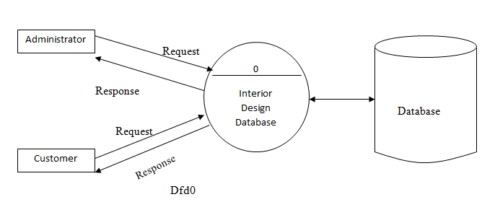

3.2 DFD LEVEL 1

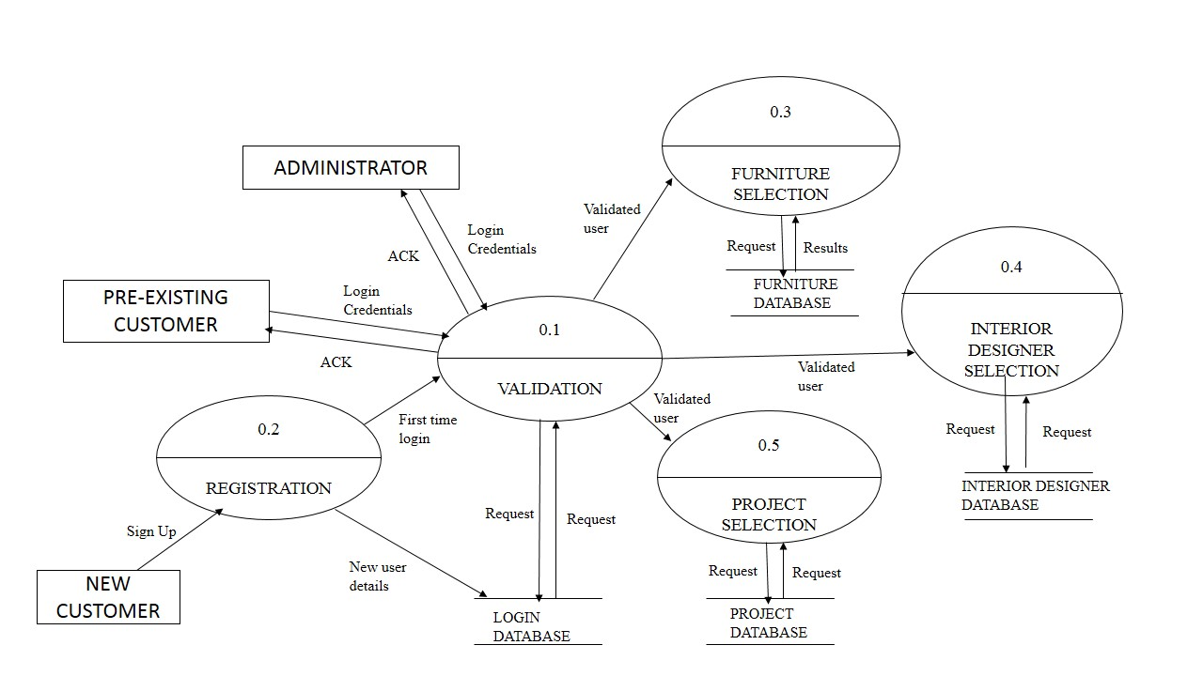

1. DFD LEVEL 2

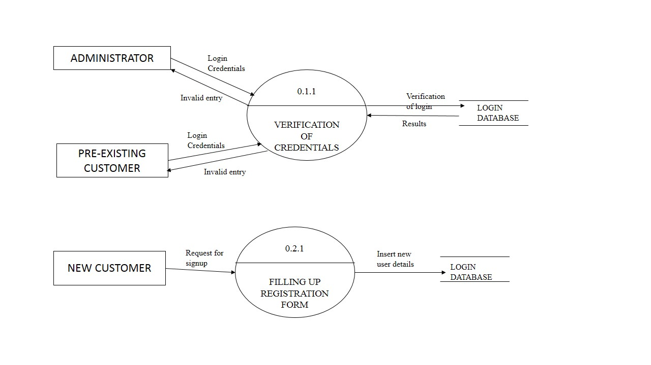

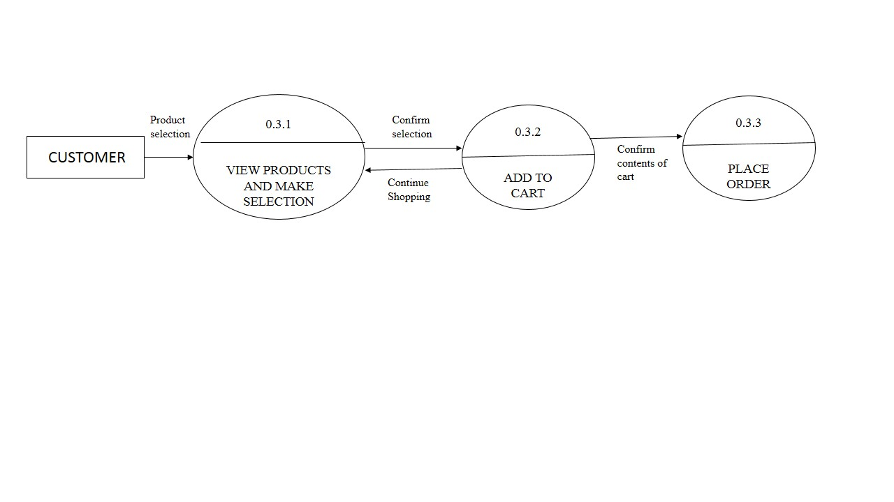

1. **ER Diagram**

Entity-Relationship Diagram depicts relationship between data objects. The attribute of each data objects noted in the entity- relationship diagram can be described using a data object description.

ER diagram serves two purposes:

* To provide an indication of how data are transformed as they move through the system.
* To depict the functions that transformation the data flow.

Data Objects:

A data object is a representation of almost any composite information that must be understood by the software. By composite information, we mean something that has a number of different properties or attributes. A data object encapsulates data only there is no reference within a data object to operations that act on the data.

Attributes:

Attributes define the properties of a data object and take on one of three different characteristics. They can be used to:

* Name an instance of data object.
* Describe the instance.
* Make reference to another instance in other table.

Relationships:

Data objects are connected to one another in a variety of different ways. We can define a set of object relationship pairs that define the relevant relationships.

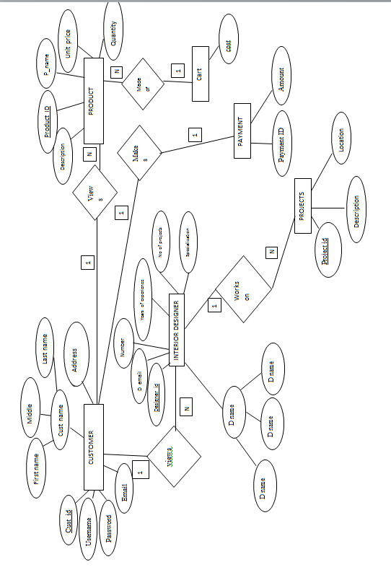

1. **Relational Schema & Normalization**

**5.1 Schema diagram**

Customer

|  |  |  |  |  |  |
| --- | --- | --- | --- | --- | --- |
| Customer_id | First name | Middle name | Last name | username | password |

Login details

|  |  |  |  |
| --- | --- | --- | --- |
| Customer_id | username | password | Login time |

Interior designer

|  |  |  |  |  |  |
| --- | --- | --- | --- | --- | --- |
| Designer_id | First name | Middle name | Last name | No of projects | Years of experience |

Designer contact details

|  |  |  |  |  |
| --- | --- | --- | --- | --- |
| Designer_id | email | specialization | Phone number | location |

Product

|  |  |  |  |  |
| --- | --- | --- | --- | --- |
| Product_id | Name | Unit price | Quantity | description |

Project

|  |  |  |  |  |
| --- | --- | --- | --- | --- |
| Project_id | Designer_id | Cost | Location | description |

Order2

|  |  |  |
| --- | --- | --- |
| Order_id | Customer_id | Amount |

Cart

|  |  |  |  |
| --- | --- | --- | --- |
| Customer-ID | Product-id | Quantity | Unitprice |

**5.2 Normalization**

Normalization of data can be considered as a process of analyzing the given relational schema based on their functional dependencies and primary keys to achieve the desirable properties of minimizing redundancies and minimizing Insertion, Deletion and Updation anomalies.

Normal form of a relation indicates the degree to which it has been normalized.

**1NF**: 1NF disallows relations within relations or relation as attribute values within tuples.  
**2NF**: A relational schema R is in 2NF if every non prime attribute A’ in R is fully functionally dependent on primary key of R.

**3NF** : A relational schema R is in 3NF if, whenever a non trivial functional dependency X -> A holds in R, either a) X is a superkey of R or b) A is a prime attribute of R.

As the developers see here, all the primary keys consist of single attributes and there are no multivalued dependencies, partial dependencies or any sort of a joint dependency. Hence the schema is in 5NF.

1. **Reports**
   1. REPORT 1: List of all products as visible to the admin with available quantity

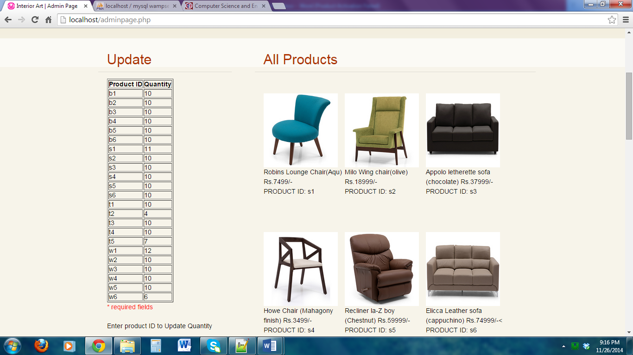

REPORT 2: List of all registered users as visible to admin

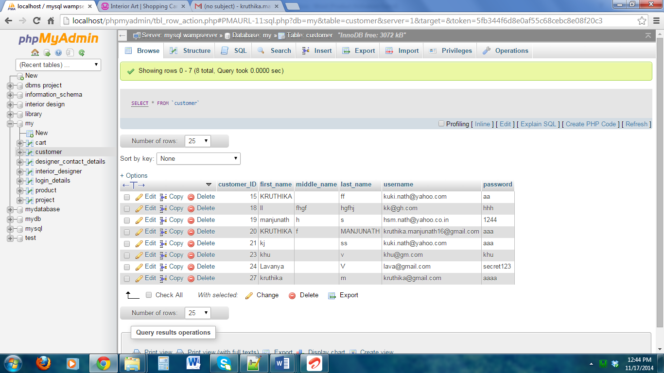

REPORT 3: List of products in cart as visible to a customer

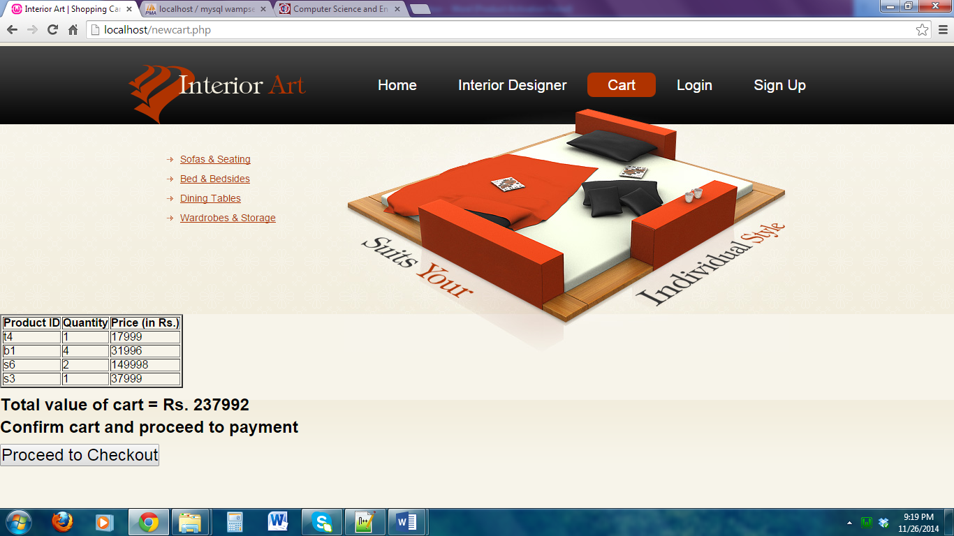

REPORT 4: Time stamp of login of users as visible to admin

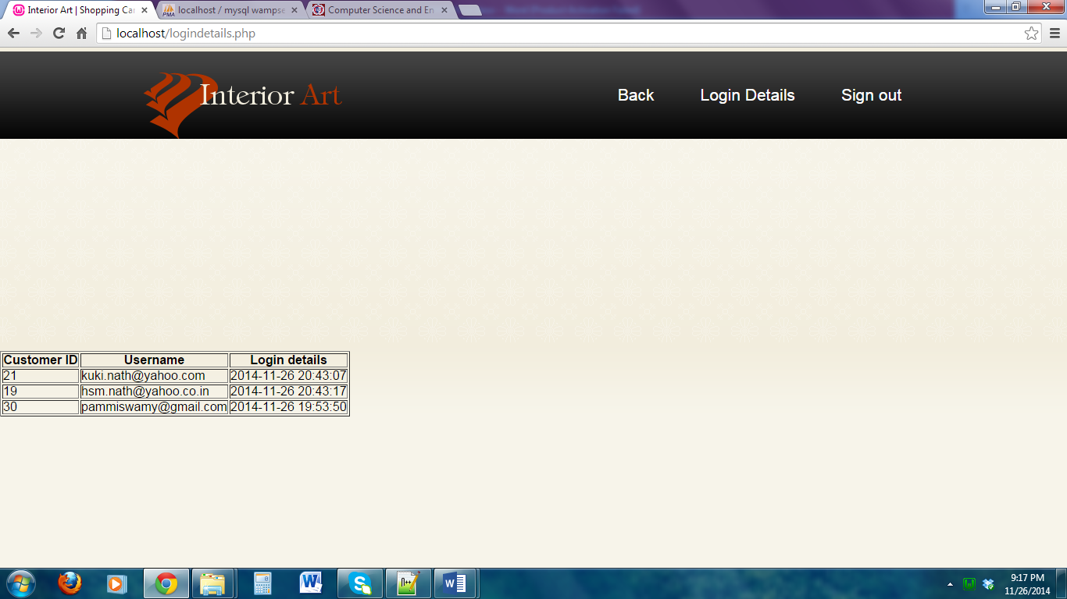

1. **Conclusion**
   1. **Summary**

The Interior Design Database Management System which we implemented is very flexible and user friendly. It takes care of valid logins, both at the user and at the admin- level. After logging in, the user can view range of furniture including sofas, dining table, wardrobe and bed & bedsides. The user can select the products he wishes to buy and add to his shopping cart. The admin can add/delete the list of products the user can select from.

The user also has an added feature to view list of interior designers and their projects. We also provide their contact details to help customers assign projects to their desired designers.

There are several modifications that can be made to the existing model, to overcome the existing limitations. These limitations and future enhancements are listed below.

**7.2 Limitations**

* Lack of a method of interaction between customer and interior designer.
* Limited variety of products which limits the user to make choices.
* Online payment for ticket booking is not provided.

**7.3 Future Enhancements**

* Provision to add more designers and projects. To provide a real time interaction between the designers and the customers.
* Improve the range of products and their variety and apply filters to choose products.
* Online payment is another facility that could greatly improve the applicability of the project.

8. REFERENCES

1. Ramez Elmasri and Shamkant V Navathe, Fundamentals of Database Systems, 5th Edition, Addison-Wesley Publications, 2007
2. Raghu Ramakrishnan and Johannes Gehrke, Database Management Systems, 3rd Edition, McGraw-Hill Publications, 2003
3. Luke Welling and Laura Thompson, PHP and MySQL Web Development, 3rd Edition, Paperback Publications- 2004

[4] www.urbanladder.com

[www.pepperfry.com](http://www.pepperfry.com)

[www.interiors-furniture.com](http://www.interiors-furniture.com)

[www.kuviostudio.com](http://www.kuviostudio.com)

[www.ashwinarchitects.com](http://www.ashwinarchitects.com)

[www.aishwaryainteriors.com](http://www.aishwaryainteriors.com)

[www.savioandrupa.com](http://www.savioandrupa.com)

[www.cozynestinteriors.com](http://www.cozynestinteriors.com)

1. **Appendix (Snapshots)**

1 Basic login page

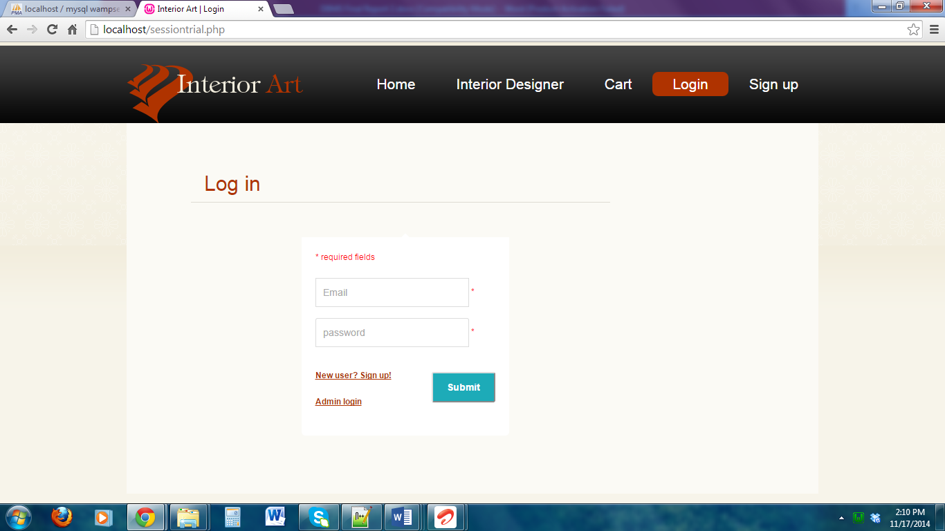

1. Admin login page

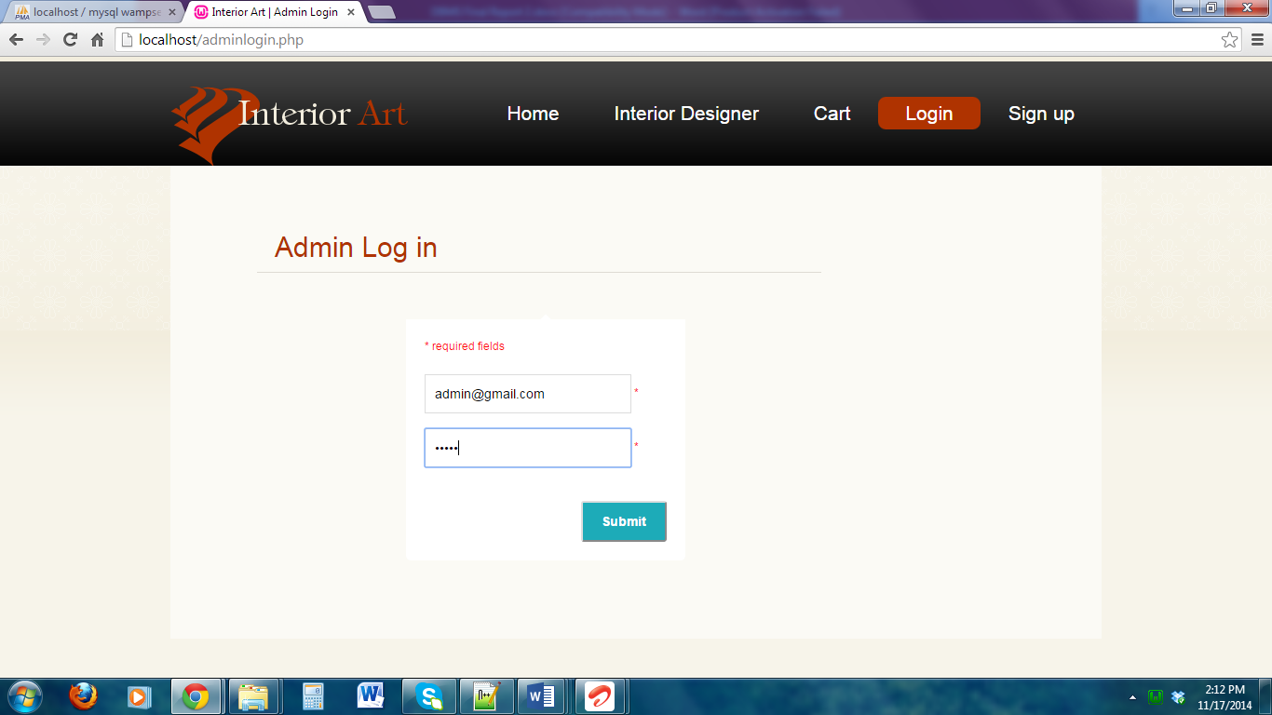

1. Admin page on login

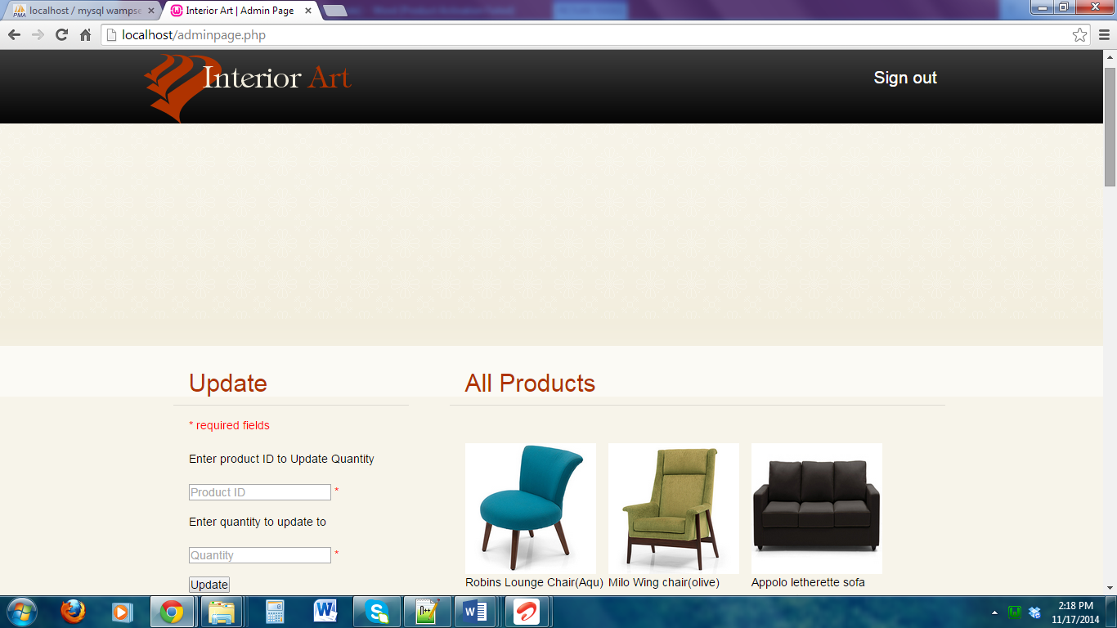

1. Admin on updating the product quantity

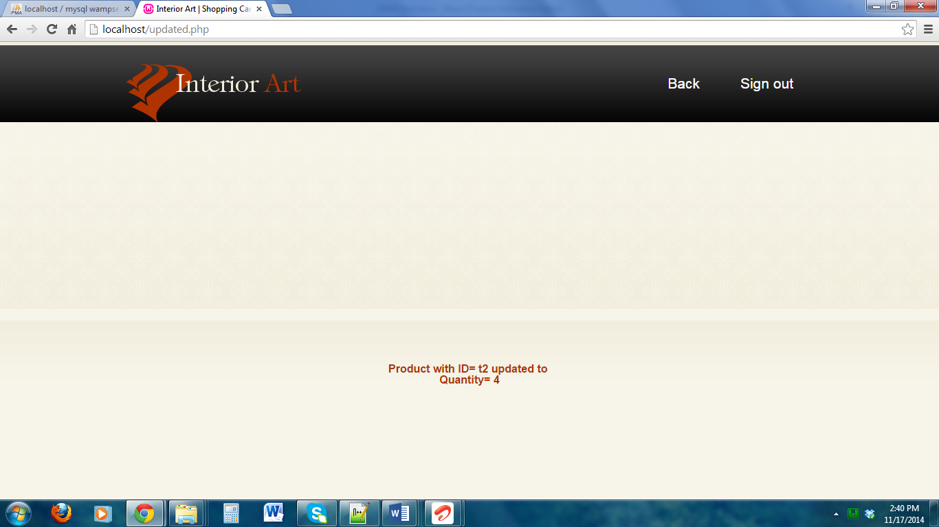

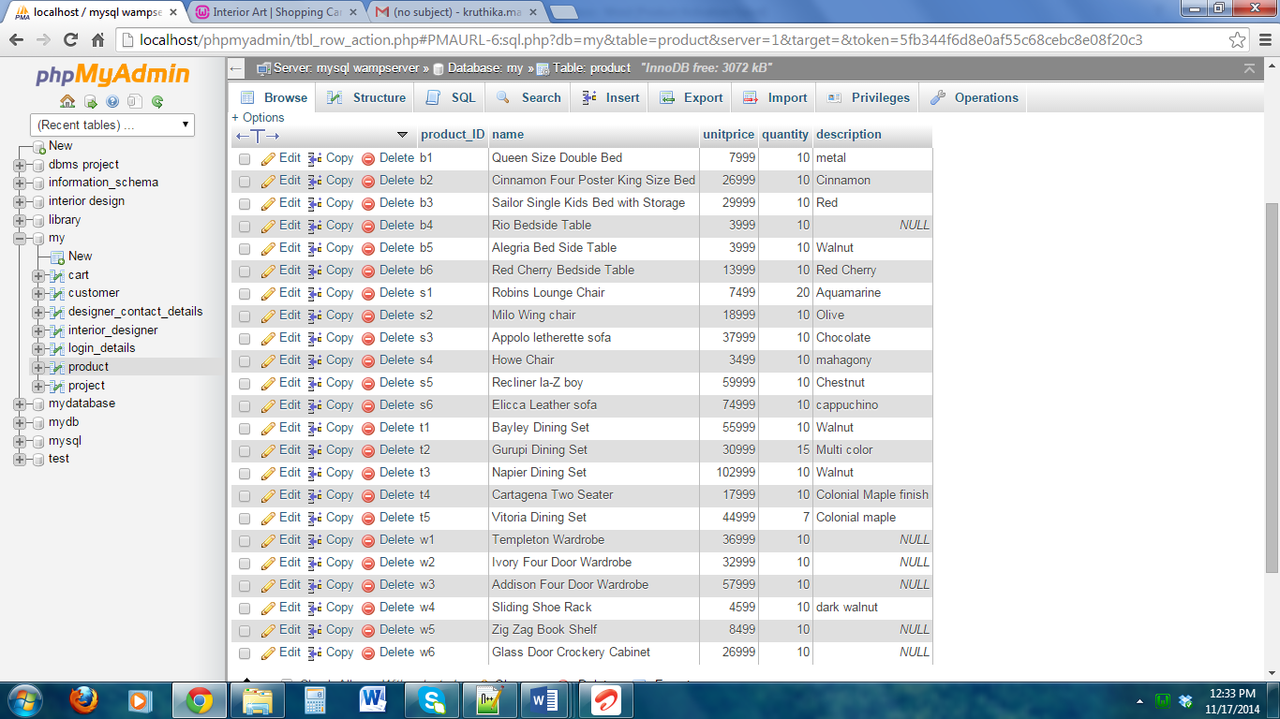

1. New user registration form

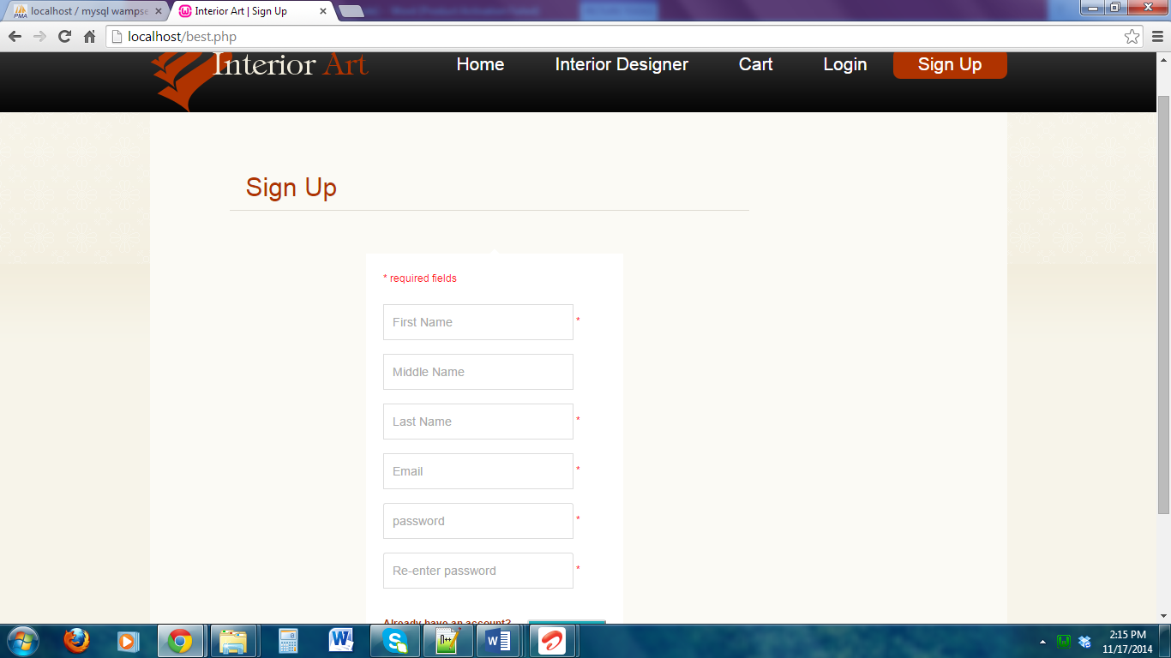

1. User page on successful login

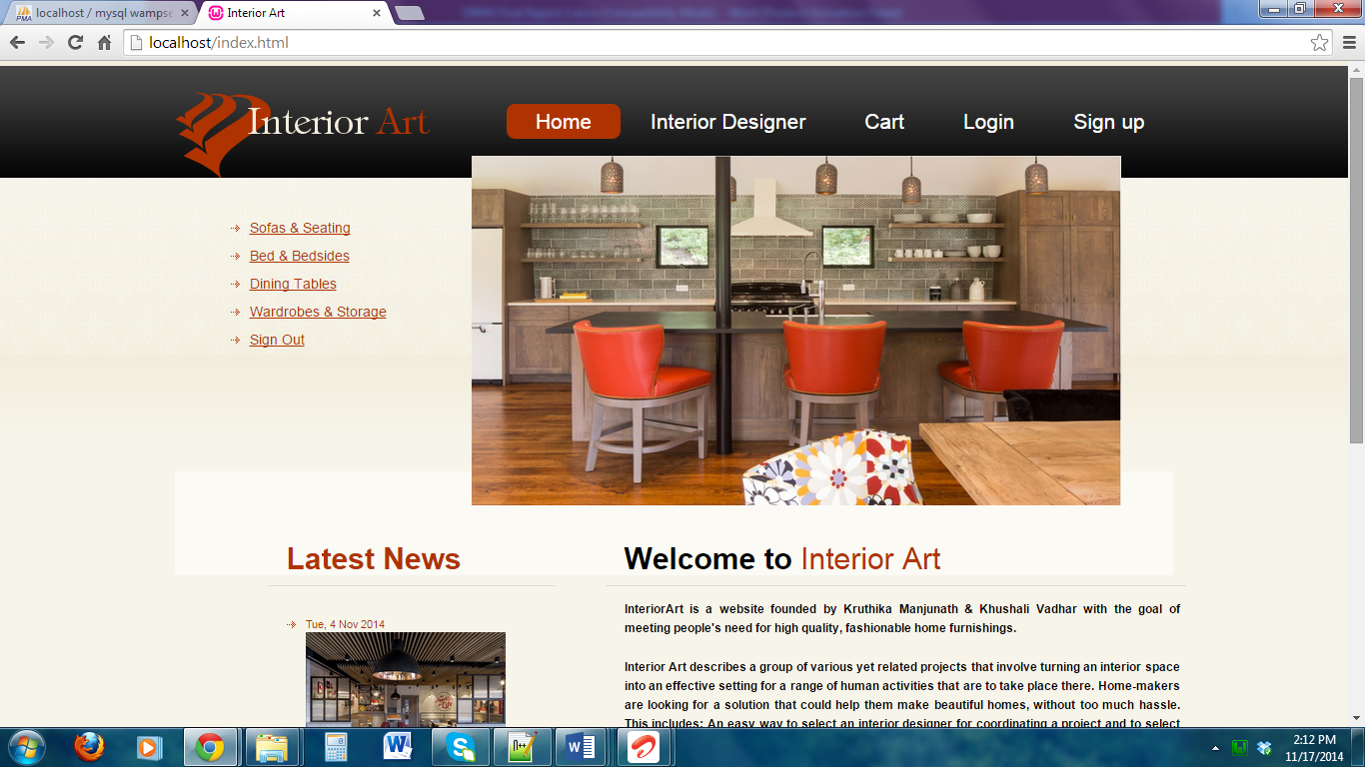

1. One of the Interior designer page

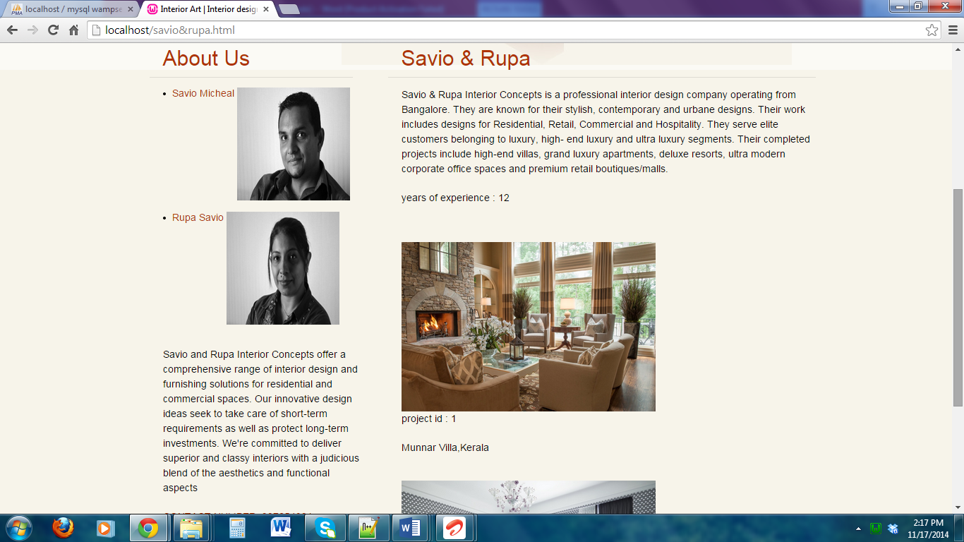

1. All the products page

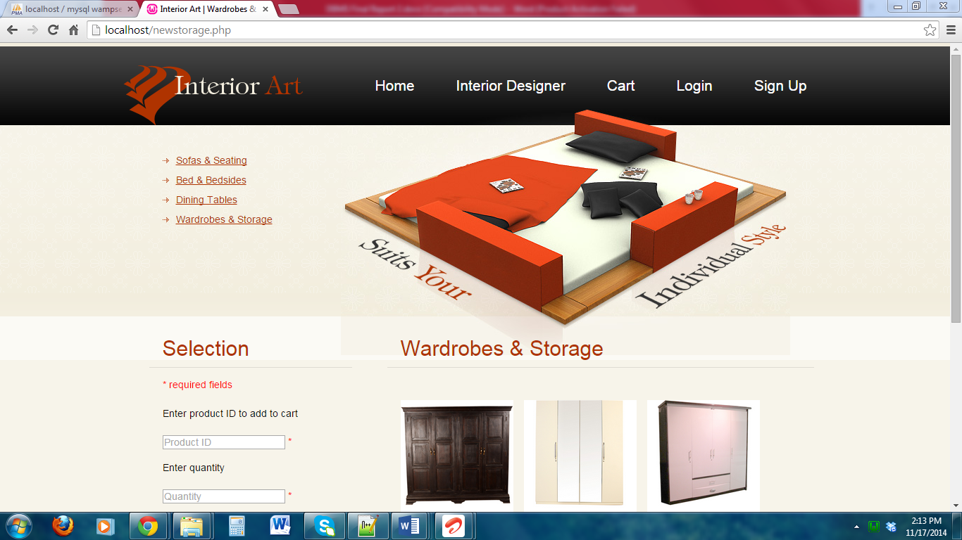

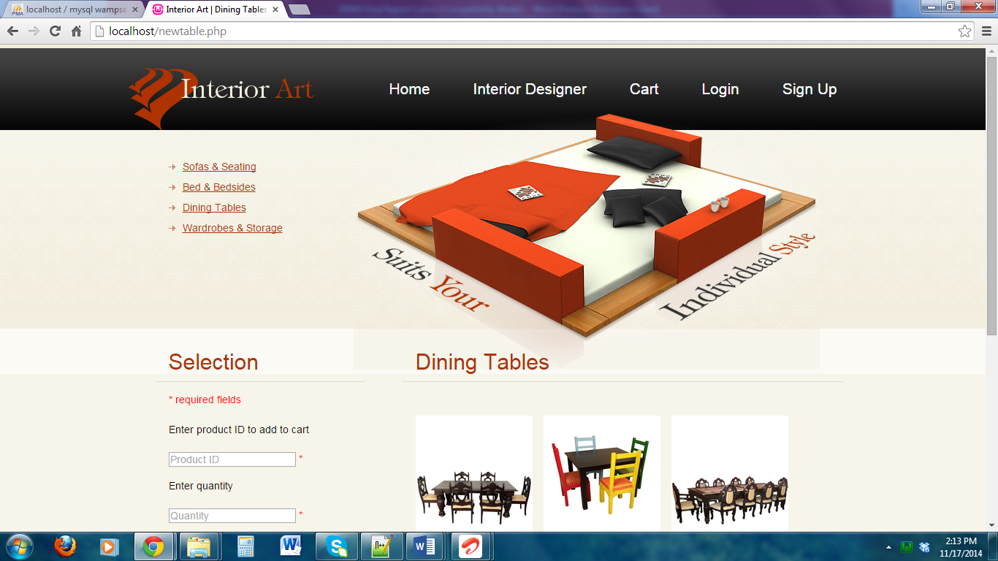

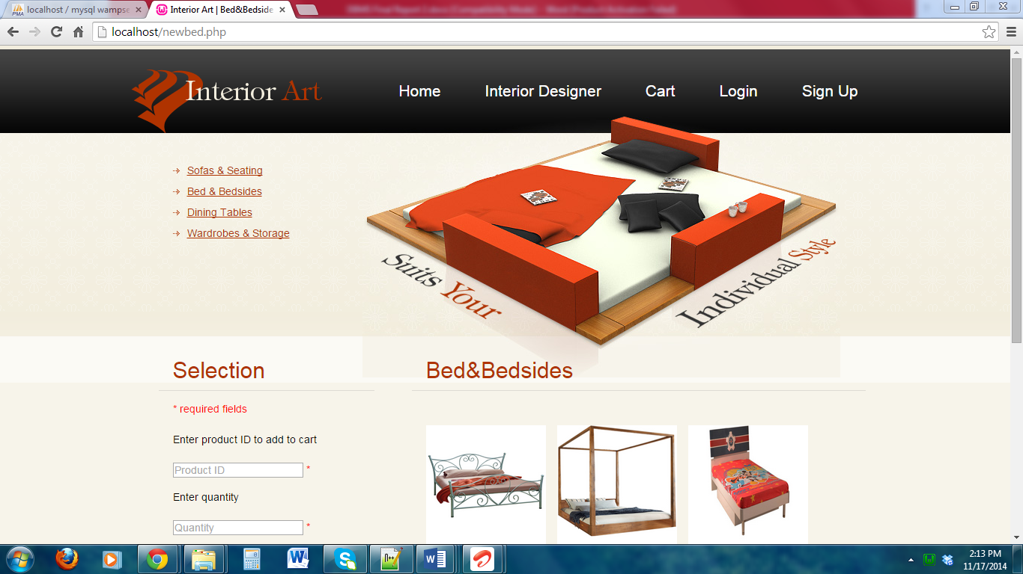

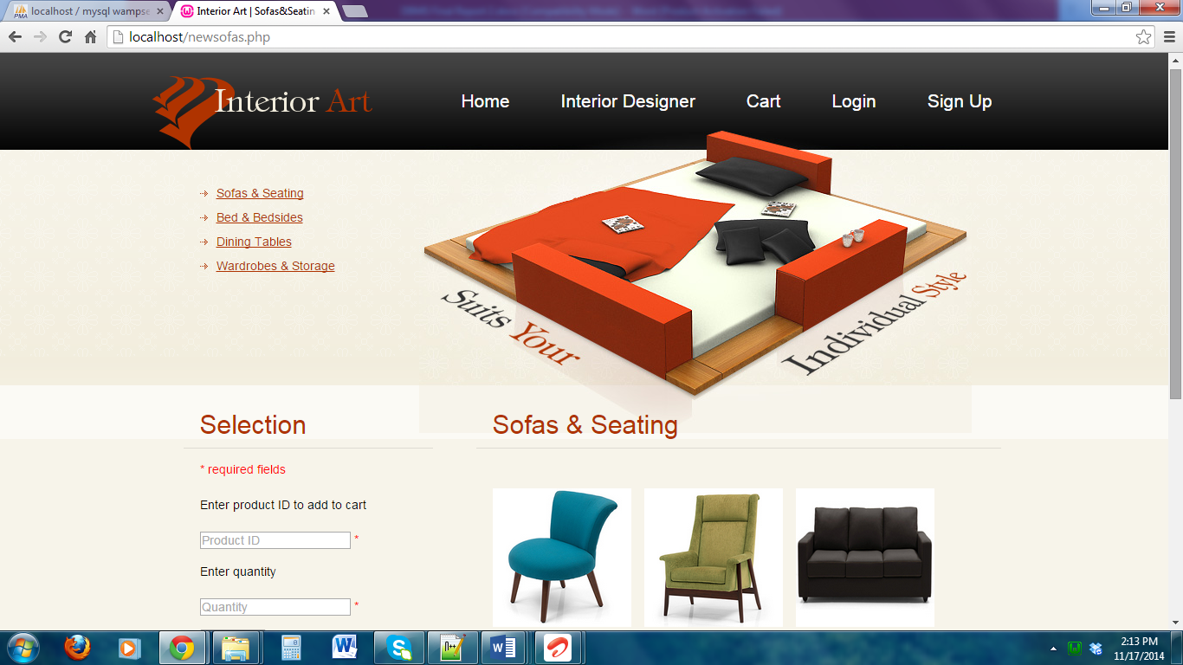

1. User shopping cart after adding products

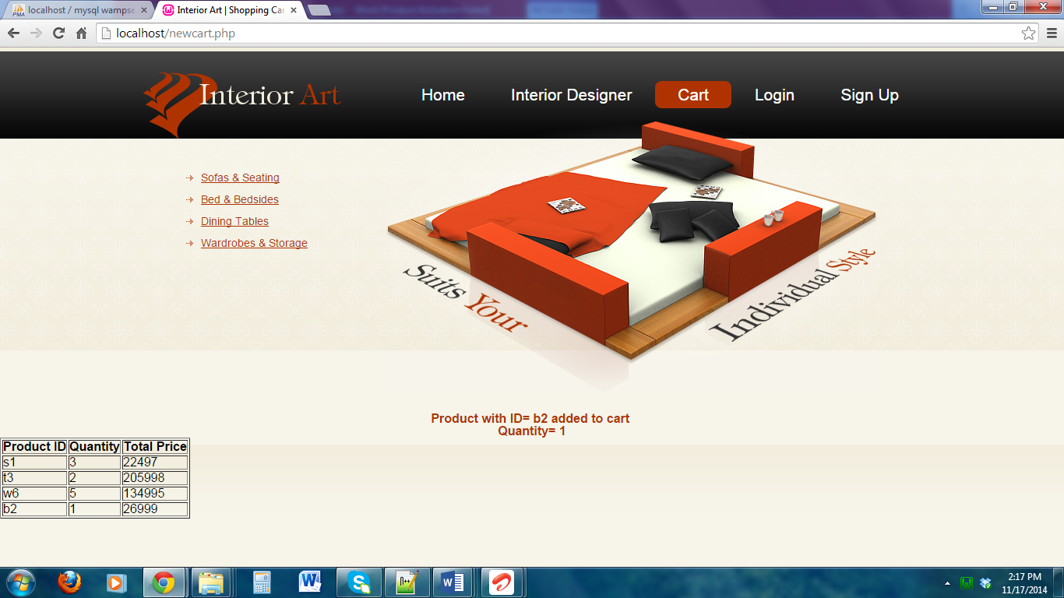

10 Logout page

